OKN1 Task 1: Using AI to Resolve Challenges

Deven Lee
Western Governors University
D804: Advanced AI for Computer Scientists
September 16, 2025

Using AI to Resolve Challenges: Two Mini-Projects

Introduction
This paper presents two AI mini-projects aligned with the competencies of the D804 OKN1 assessment: (1) an advanced model using XGBoost on the Adult Income dataset, and (2) a probabilistic model using Naive Bayes on the Seaborn Titanic dataset. Each project includes data preparation, model training, validation, and an outline for deployment. Optimization work demonstrates performance tuning and evaluation benchmarks.

Model 1: D804_PA_Model_AdultIncome_XGB

Goal
Predict whether an individual’s income exceeds $50K based on census attributes.

Dataset
- Source: OpenML “adult” (ID: 1590). The Adult dataset (originally from UCI) contains demographic and employment features for income prediction (Dua & Graff, 2017).
- Features: Mixed categorical (e.g., workclass, education, occupation) and numerical (e.g., age, hours-per-week, capital-gain).
- Target: income (>50K or <=50K).

Why This Dataset
- It is a well-known benchmark for tabular classification and fairness considerations.
- Sufficient size and feature diversity to showcase advanced tree-based modeling.

Data Preparation
- Standardized column names (replace hyphens with underscores).
- Train/validation split (stratified by target) and preprocessing in the training script, including:
  - Handling missing values.
  - One-hot encoding for categorical variables.
  - Numeric features retained without scaling (tree-based models are scale-invariant).

Method and Development
- Advanced method: Gradient-boosted decision trees using XGBoost, a scalable tree-boosting system (Chen & Guestrin, 2016).
- Scripts: scripts/model1_xgboost_adult/{fetch_data.py, train.py, evaluate.py, optimize.py}.
- Training includes defaults for depth, learning rate, estimators, and early stopping when supported.

Training and Validation
- Metrics: accuracy, precision, recall, F1 (macro/weighted), ROC-AUC when probabilities are available.
- Validation via held-out split; cross-validation is optionally used in optimization.

Deployment Plan
- Package preprocessing (encoder) and model into a pipeline.
- Expose the prediction endpoint via FastAPI; add input validation and simple health checks.
- Optional: containerize for portability and deploy to a managed service.

Code Documentation
- The scripts document functions, parameters, and return values inline; the README explains run steps and naming.

Model 2: D804_PA_Model_Titanic_NB

Goal
Predict passenger survival from the Titanic dataset using a probabilistic approach.

Dataset
- Source: Seaborn's Titanic dataset (Waskom, 2021).
- Features subset: survived, pclass, sex, age, sibsp, parch, fare, embarked, class, who, adult_male, deck, embark_town, and alone.
- Target: survived (0/1).

Why This Dataset
- Classic probabilistic modeling example with mixed data types and missingness.
- Clear interpretability for demonstrating Naive Bayes assumptions.

Data Preparation
- Column subset selection for consistency.
- Imputation of missing values; encoding of categorical variables to numeric representation.

Method and Development
- Probabilistic method: Naive Bayes (GaussianNB after encoding/imputation; CategoricalNB where applicable) as implemented in scikit-learn (Pedregosa et al., 2011).
- Scripts: scripts/model2_nb_titanic/{fetch_data.py, train.py, evaluate.py, optimize.py}.

Training and Validation
- Metrics: accuracy, precision, recall, F1 (macro/weighted), ROC-AUC if probability outputs are available.
- Held-out validation split used for evaluation.

Deployment Plan
- Persist preprocessing and NB model.
- Provide a lightweight API endpoint for batch and single predictions, with schema validation.

Code Documentation
- Inline comments and docstrings; README guides how to fetch data, train, evaluate, and optimize.

Optimization and Evaluation

Project Names
- D804_PA_Optimization_AdultIncome_XGB
- D804_PA_Optimization_Titanic_NB

Actions Performed
- Hyperparameter tuning: learning rate, max_depth, n_estimators for XGB; smoothing/prior parameters for NB.
- Efficiency measurements: fit/predict time and model size.

Benchmarks and Evaluation
- Benchmarks: F1-score (primary), accuracy, confusion matrix; timing for training and inference.
- Models evaluated against these metrics on held-out validation sets; optimization selects configurations that balance performance and efficiency.

Results (Held-out Validation)
- Adult XGBoost: accuracy ≈ 0.876, F1 ≈ 0.717, ROC-AUC ≈ 0.930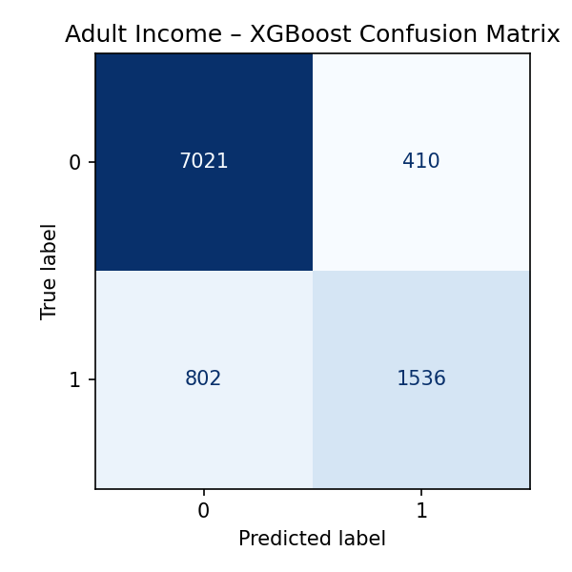

  - Confusion matrix – XGBoost
- Titanic Naive Bayes: accuracy ≈ 0.765, F1 ≈ 0.712, ROC-AUC ≈ 0.813
  - 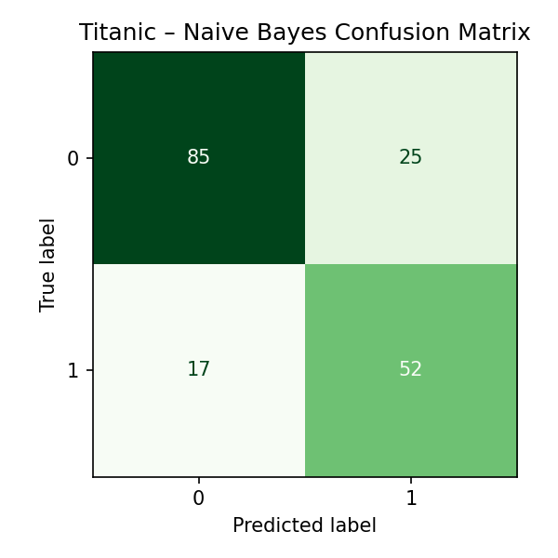
  - Confusion matrix – Naive Bayes

Conclusion
These mini-projects demonstrate preparation, modeling, validation, and optimization of AI systems using both advanced (XGBoost) and probabilistic (Naive Bayes) techniques. The codebase is structured for clarity and reproducibility, and the deployment path is defined for production handoff. This work aligns with the performance assessment competencies and is ready for submission.

References
Chen, T., & Guestrin, C. (2016). XGBoost: A scalable tree boosting system. In Proceedings of the 22nd ACM SIGKDD International Conference on Knowledge Discovery and Data Mining (pp. 785–794). https://doi.org/10.1145/2939672.2939785
Dua, D., & Graff, C. (2017). UCI Machine Learning Repository: Adult Data Set. https://archive.ics.uci.edu/ml/datasets/adult
Pedregosa, F., Varoquaux, G., Gramfort, A., et al. (2011). Scikit-learn: Machine learning in Python. Journal of Machine Learning Research, 12, 2825–2830.
Waskom, M. (2021). Seaborn: Statistical data visualization. Journal of Open Source Software, 6(60), 3021.

